

**CMPE 211 Course Project**

Project Name : ***TEDUpolly***

Group Name : **La Petit Project (Section 1)**

Group Members :

* Fuat Yiğit KOÇYİĞİT - 16429085948
* Günsu GÜNAYDIN - 18098680134
* Sudenur ATA - 10014062970
* Yunus NOGAY - 41953436140

**Contents**

* Project Description (3)
* Functionality (4-5)
* Introduction of the game (6-7)
* Workload Division (8)

**Project Description**

The game we are planning to do (TEDUpolly) will be a game based on the Monopoly game but it will be changed and arranged for TEDU and students so it will have some differences inside it.

The game can be played with minimum 2, maximum 4 players. All players will start with the same amount of money and all players will recieve money when they passed the start point. One player (after the first dice throw. The game will start with the one who diced the biggest number) will start the game with throwing dice. The players will only be able to buy the location if they are on that location and the location is independent (not owned by anybody). If they are on other player’s location (that other player bought) they had to pay the rent to the player. And also there will be some special squares on the board.

Player will throw the dice and will choose if he wants to buy the locaiton or not. He had to be careful about his/her Money because if he/she doesn’t have money to pay rent, he/she will had to sell some of his/her properties. If he/she still doesn’t have enough money, the player will lose the game. Also the game will have limited turns to restrict the endless games. If the turns have reached the limit or only one one player left (other players lost the game), the game will choose the winner.

**Functionality**

The game will ask to the user to how many players will play and then ask for the name of every player. The game will call them as the name they entered (in transactions etc.) We will say “student” to every player in the game.

Then it will create the account for all players and will give them the starting money ($25.000). Every player will see their money when the turn came to them and they will also see the transactions that happened.

Then the game will specify the play order of the players according to the first dice they throw (there will be “Roll Dice” button and we will try to add dice animation).

The game will start with the first player’s dice throw. If the player came to a location (independend place) there will be two button for buying the location or passing (every location has different cost and also different rent. Rents will increase so much with the house or hotel on it). After the player selected his/her choose he/she will select “Next Turn” button and then turn will go to the next player and he/she will throw the dice with selecting “Roll Dice” button.

If the player owns all the places in the same color, he/she will be able to build a house when he/she came to one of that places with the “Build” button (building a house has a cost but it will increase rent). If the player already has house on the every square on the same color, he will be able to build hotel with the “Build” button (building a hotel also has a cost but it will increase rent greatly). There will also be buttons for build a house/hotel or pass.

If player came to a square where another player bought, he/she had to pay rent with the “Pay” button. If he/she doesn’t have enough money to pay the rent, game will automaticly sell his/her cheapest property to the bank with its half value until he/she has enough money to pay. The places that sold to the bank will automaticly be independent and another players will be able to buy them if they came to that square. Also if he/she still hasn’t got enough money after selling all his/her property, player will lose the game and the game will automatically pass that player’s turn everytime.

The Buy/Pay/Build/Pass will be one turn of a player and the next turn will be start after the player pressed “Next Turn” button.

Every player’s dice result will be recorded and they will recieve scholarship money from the starting point according to their average. (Higher dice average will get more scholarship money when he/she passed the start point and lower dice average will get less scholarship money when he/she passed the start point.) And at the end of the game (if the turn limit (112 turn) finishes), every player’s money will be multiplied with their GPA.

There will be “Registration Freeze” square. If the player came here, he/she will press the “Special” button and will not play next turn, game will automaticly pass the next turn for him and he/she will be count as he/she throwed a 0 dice.

There will be “Erasmus” square. If the player came here he/she will press the “Special” button, then he/she will pay $5.000 but his/her GPA will increse.

There will also be “Suprise” square. He/She will press the “Special” button and then game will automatically show him the suprize card and made the transiction (if needed). This suprize card will be selected randomly and can be anything (for example go to the “Freeze”, you won $10k money etc.).

When every player played their turn (for example if 4 players are playing, after 4 turn) the game will count that as 1 week (players will be able to see the week number). And the game will be limited with 112 weeks (since a period is 14 week, 14 week * 8 period = 112 week). After 112 week, the richest player ([money + property value] * GPA) will win. If all other players lost the game (don’t have money) the last one will automatically win (don’t need to wait for 112 week).

We are planning to show all the functionalities of the game and its simple, smooth and bugless interface at the demo date.

**Introduction of the Game**

The game will have a board, information square (will show the money of the current student and the transactions) and buttons (Buy, Pass, Pay, Build, Next Turn) and every student will have a color (White, Red, Blue, Green) that will show them where they are. Board will also show the costs of squares (boughtable ones), the owners of the places and also the houses/hotels on the squares.

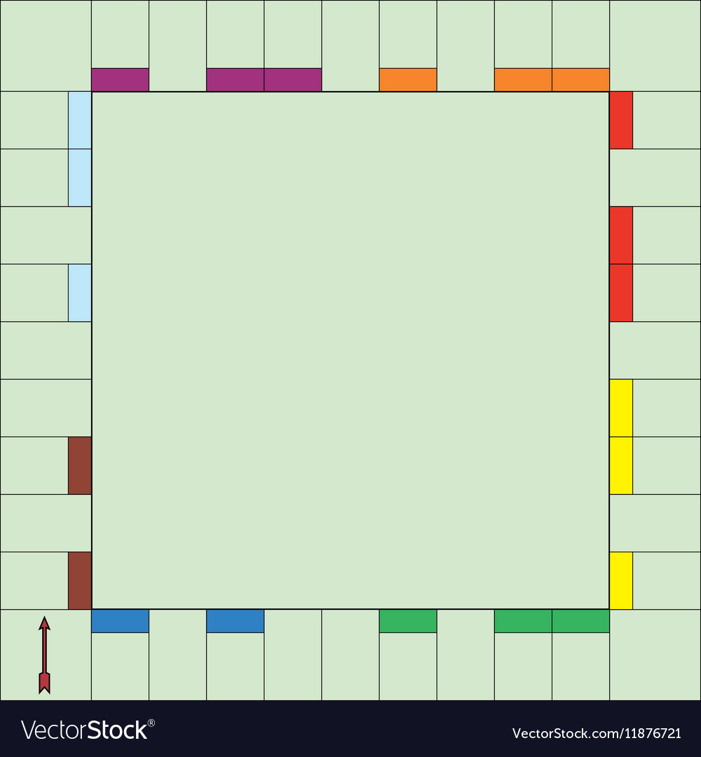

*The Game Board will be like this with special square names and values that we will choose. And in the middle, there will be “TEDUpolly” emblem and we will try to do a dice throw animation.*

All students will start the game with $250.000 money.

Firstly, there will be a dice throw to specifiy the play order. (Higher dice will play first.)

After that, game will start according to that order. First student will throw the dice.

The student will be able to buy the place if it is not owned by another student (independent place) and if he/she has enough money to buy (he/she can also choose not to buy and pass). If another player has that place, he/she had to pay rent. If he/she doesn’t have money to pay, the game will automatically sell his/her places until he/she has enough money to pay the rent. If he/she still doesn’t have enough money, student will de-registrate and lose the game.

There will be some special squares called “Registration Freeze”, “Erasmus” and “Suprise”. “Registration Freeze” square will make student freeze the next turn (he/she will still be able to get money if another student came to his/her place but he/she can not move). “Erasmus” square will cost student $5.000 money but will increase his/her GPA. “Suprize” square will give student a suprize card. That suprise card will be randomly selected and can be anything (for example go to the “freeze”, you won $10k money etc.).

Every dice of the student will be recorded as his/her grade (1= 1.0 , 2= 2.0 , 3= 2.5 , 4= 3.0 , 5= 3.5 , 6= 4.0) and student will have an active GPA. This GPA will affect their scholarship. Every student will get scholarship (money) proportional to his/her GPA (higher GPA means higher scholarship, lower GPA means lower scholarship). Students will get their scholarship everytime when they passed the START square.

The aim of the game is to finish the game as the richest and successeful student or eleminate other students and be the last one standing.

**Workload Division**

* Fuat Yiğit Koçyiğit: Code Part (Functuonalities)
* Günsu Günaydın: Visual Part (User Interface)
* Sudenur Ata: Code Part (Functuonalities)
* Yunus Nogay: Visual Part (User Interface)

*The workload divisions are not fully certain. We may change and arrange the workload divisions according to the requirements.